Instructions for Making Abilities Ratings

These questions are about job-related activities. An ability is an enduring talent that can help a person do a job. You will be asked about a series of different abilities and how
they relate to your current job – that is the job you hold now.

Each ability in this questionnaire is named and defined.

For example:
Arm-Hand Steadiness | The ability to keep your hand and arm steady while moving your arm or while holding your arm and hand in one position.

You are then asked to answer two questions about that ability:
A

How important is the ability to your current job?

For example:

How important is ARM-HAND STEADINESS to the performance of your current job?
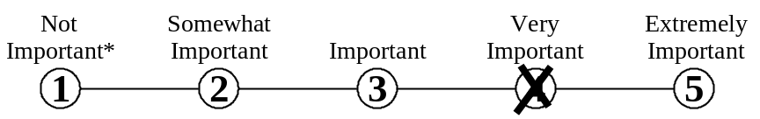

Mark your answer by putting an X through the number that represents your answer.
Do not mark on the line between the numbers.

*If you rate the ability as Not Important to the performance of your job,
mark the one [ ] then skip over question B and proceed to the next ability.

B

What level of the ability is needed to perform your current job?

To help you understand what we mean by level, we provide you with examples of
job-related activities at different levels for each ability. For example:

What level of ARM-HAND STEADINESS is needed to perform your current job?
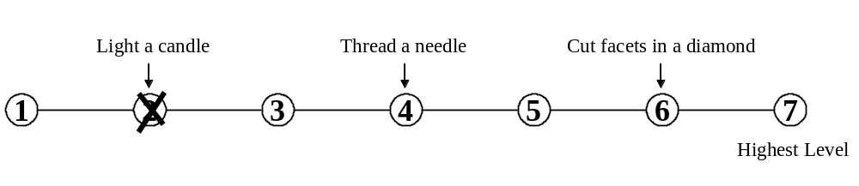

Mark your answer by putting an X through the number that represents your answer.
Do not mark on the line between the numbers.

- Oral Comprehension | The ability to listen to and understand information and ideas presented through spoken words and sentences.
A. How important is ORAL COMPREHENSION to the performance of your current job?
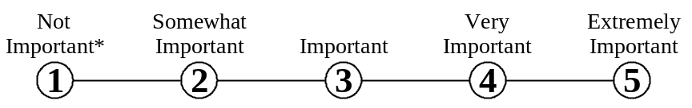

* If you marked Not Important, skip LEVEL below and go on to the next activity.

B. What level of ORAL COMPREHENSION is needed to perform your current job?
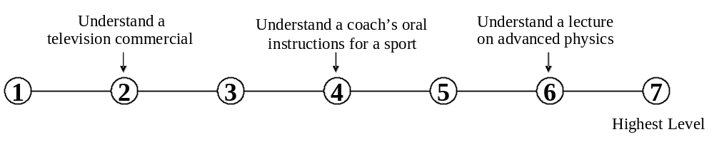

- Written Comprehension | The ability to read and understand information and ideas presented in writing.
A. How important is WRITTEN COMPREHENSION to the performance of your current job?

* If you marked Not Important, skip LEVEL below and go on to the next activity.

B. What level of WRITTEN COMPREHENSION is needed to perform your current job?
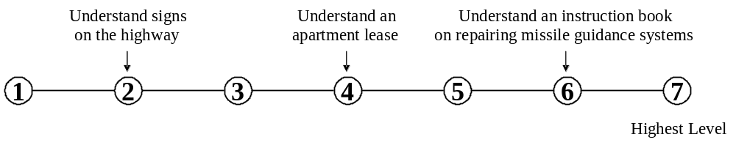

3. Oral Expression | The ability to communicate information and ideas in speaking so others will understand.
A. How important is ORAL EXPRESSION to the performance of your current job?

* If you marked Not Important, skip LEVEL below and go on to the next activity.

B. What level of ORAL EXPRESSION is needed to perform your current job?
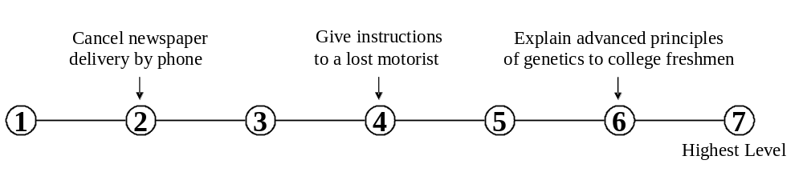

4. Written Expression | The ability to communicate information and ideas in writing so others will understand.
A. How important is WRITTEN EXPRESSION to the performance of your current job?

* If you marked Not Important, skip LEVEL below and go on to the next activity.

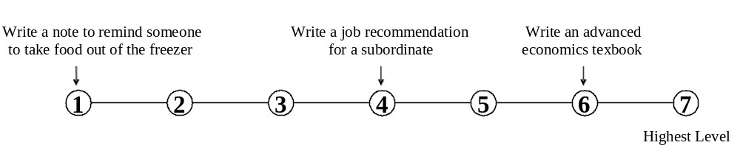B. What level of WRITTEN EXPRESSION is needed to perform your current job?

5. Fluency of Ideas | The ability to come up with a number of ideas about a topic (the number of ideas is important not their quality, correctness, or creativity).
A. How important is FLUENCY OF IDEAS to the performance of your current job?

* If you marked Not Important, skip LEVEL below and go on to the next activity.

B. What level of FLUENCY OF IDEAS is needed to perform your current job?
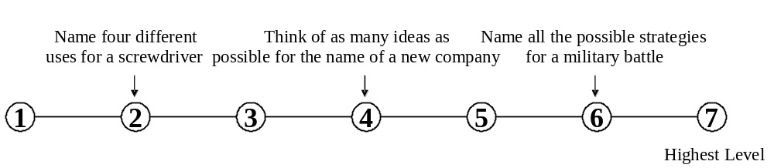

6. Originality | The ability to come up with unusual or clever ideas about a given topic or situation, or to develop creative ways to solve a problem.
A. How important is ORIGINALITY to the performance of your current job?

* If you marked Not Important, skip LEVEL below and go on to the next activity.

B. What level of ORIGINALITY is needed to perform your current job?
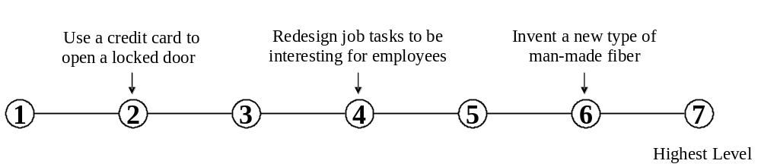

7. Problem Sensitivity | The ability to tell when something is wrong or is likely to go wrong. It does not involve solving the problem, only recognizing that there is a problem.
A. How important is PROBLEM SENSITIVITY to the performance of your current job?

* If you marked Not Important, skip LEVEL below and go on to the next activity.

B. What level of PROBLEM SENSITIVITY is needed to perform your current job?
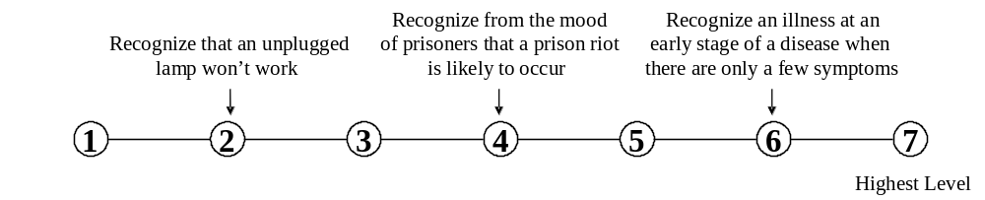

- Deductive Reasoning | The ability to apply general rules to specific problems to produce answers that make sense.
A. How important is DEDUCTIVE REASONING to the performance of your current job?

* If you marked Not Important, skip LEVEL below and go on to the next activity.

B. What level of DEDUCTIVE REASONING is needed to perform your current job?
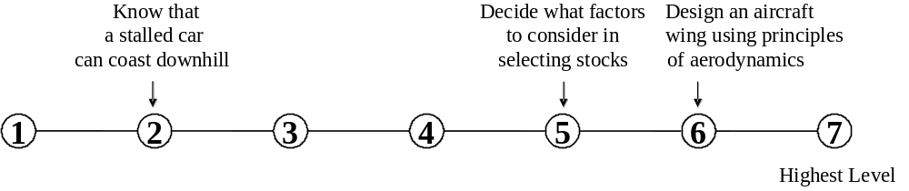

- Inductive Reasoning | The ability to combine pieces of information to form general rules or conclusions (includes finding a relationship among seemingly unrelated events).
A. How important is INDUCTIVE REASONING to the performance of your current job?

* If you marked Not Important, skip LEVEL below and go on to the next activity.

B. What level of INDUCTIVE REASONING is needed to perform your current job?
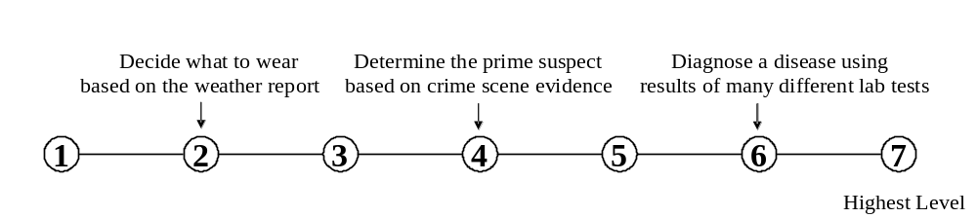

10. Information Ordering | The ability to arrange things or actions in a certain order or pattern according to a specific rule or set of rules (e.g., patterns of numbers, letters, words, pictures, mathematical operations).
A. How important is INFORMATION ORDERING to the performance of your current job?

* If you marked Not Important, skip LEVEL below and go on to the next activity.

B. What level of INFORMATION ORDERING is needed to perform your current job?
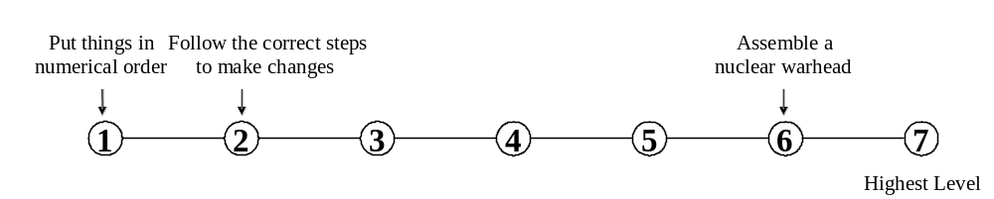

- Category Flexibility | The ability to generate or use different sets of rules for combining or grouping things in different ways.
A. How important is CATEGORY FLEXIBILITY to the performance of your current job?

* If you marked Not Important, skip LEVEL below and go on to the next activity.

B. What level of CATEGORY FLEXIBILITY is needed to perform your current job?
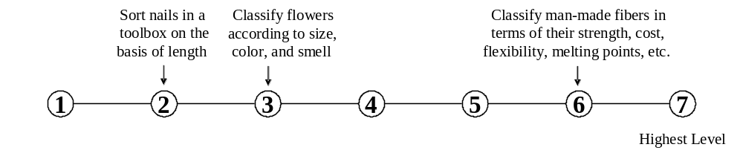

- Mathematical  Reasoning | The ability to choose the right mathematical methods or formulas to solve a problem.
A. How important is MATHEMATICAL REASONING to the performance of your
current job?

* If you marked Not Important, skip LEVEL below and go on to the next activity.

B. What level of MATHEMATICAL REASONING is needed to perform your current job?

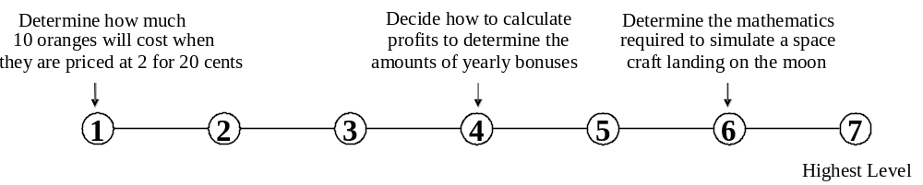

- Number Facility | The ability to add, subtract, multiply, or divide quickly and correctly.
A. How important is NUMBER FACILITY to the performance of your current job?

* If you marked Not Important, skip LEVEL below and go on to the next activity.

B. What level of NUMBER FACILITY is needed to perform your current job?
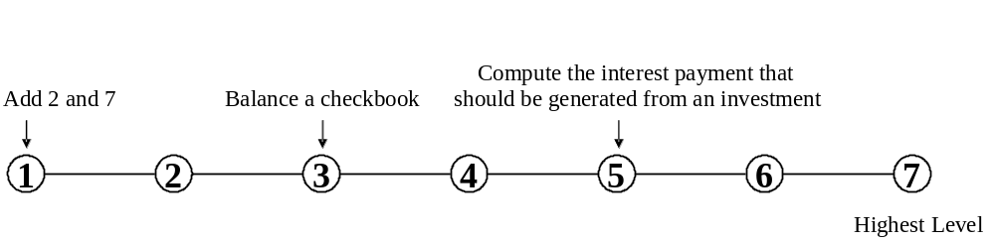

- Memorization | The ability to remember information such  as words, numbers, pictures, and  procedures.
A. How important is MEMORIZATION to the performance of your current job?

* If you marked Not Important, skip LEVEL below and go on to the next activity.

B. What level of MEMORIZATION is needed to perform your current job?

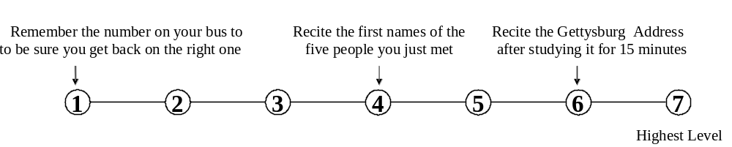

- Speed of Closure | The ability to quickly make sense of, combine, and organize information into meaningful patterns
A. How important is SPEED OF CLOSURE to the performance of your current job?

* If you marked Not Important, skip LEVEL below and go on to the next activity.

B. What level of SPEED OF CLOSURE is needed to perform your current job?
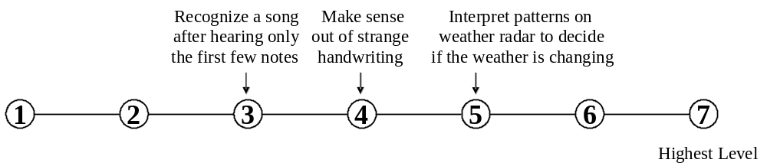

- Flexibility of Closure | The ability to identify or detect a known pattern (a figure, object, word, or sound) that is hidden in other distracting material.
A. How important is FLEXIBILITY OF CLOSURE to the performance of your current
job?

* If you marked Not Important, skip LEVEL below and go on to the next activity.

B. What level of FLEXIBILITY OF CLOSURE is needed to perform your current job?
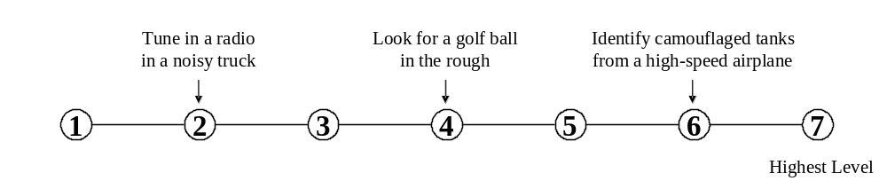

- Perceptual Speed | The ability to quickly and accurately compare similarities and differences among sets of letters, numbers, objects, pictures, or patterns. The things to be compared may be presented at the same time or one after the other. This ability also includes comparing a presented object with a remembered object.
A. How important is PERCEPTUAL SPEED to the performance of your current job?

* If you marked Not Important, skip LEVEL below and go on to the next activity.

B. What level of PERCEPTUAL SPEED is needed to perform your current job?
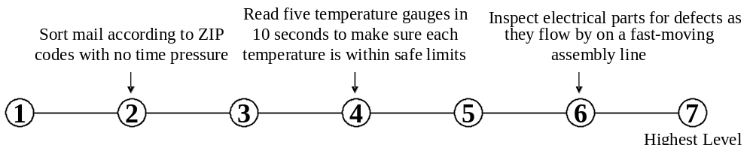

- Spatial Orientation | The ability to know your location in relation to the environment or to know where other objects are in relation to you.
A. How important is SPATIAL ORIENTATION to the performance of your current job?

* If you marked Not Important, skip LEVEL below and go on to the next activity.

B. What level of SPATIAL ORIENTATION is needed to perform your current job?
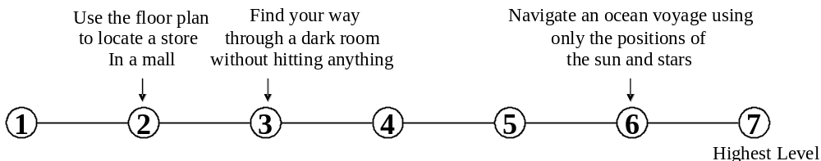

- Visualization | The ability to imagine how something will  look after it is moved around or when its  parts are moved or rearranged.
A. How important is VISUALIZATION to the performance of your current job?

* If you marked Not Important, skip LEVEL below and go on to the next activity.

B. What level of VISUALIZATION is needed to perform your current job?
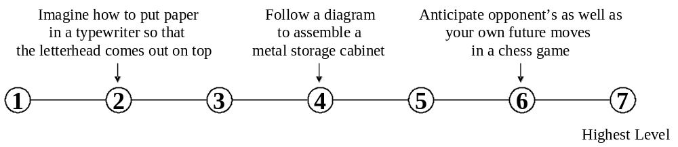

20. Selective Attention | The ability to concentrate on a task over a period of time without being distracted.
A. How important is SELECTIVE ATTENTION to the performance of your current job?

* If you marked Not Important, skip LEVEL below and go on to the next activity.

B. What level of SELECTIVE ATTENTION is needed to perform your current job?
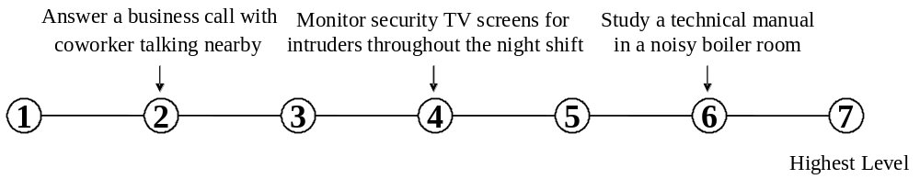

21. Time Sharing | The ability to shift back and forth between two or more activities or sources of information (such as speech, sounds, touch, or other sources).
A. How important is TIME SHARING to the performance of your current job?

* If you marked Not Important, skip LEVEL below and go on to the next activity.

B. What level of TIME SHARING is needed to perform your current job?
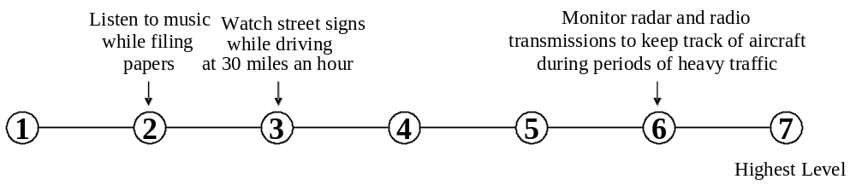

- Arm-Hand Steadiness | The ability to keep your hand and arm steady while moving your arm or while holding your arm and hand in one position.
A. How important is ARM-HAND STEADINESS to the performance of your current job?

* If you marked Not Important, skip LEVEL below and go on to the next activity.

B. What level of ARM-HAND STEADINESS is needed to perform your current job?
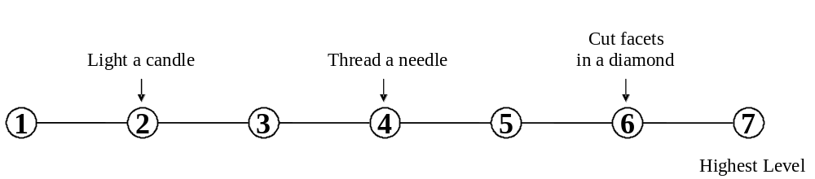

- Manual Dexterity | The ability to quickly move your hand, your hand together with your arm, or your two hands to grasp, manipulate, or assemble objects.
A. How important is MANUAL DEXTERITY to the performance of your current job?

* If you marked Not Important, skip LEVEL below and go on to the next activity.

B. What level of MANUAL DEXTERITY is needed to perform your current job?
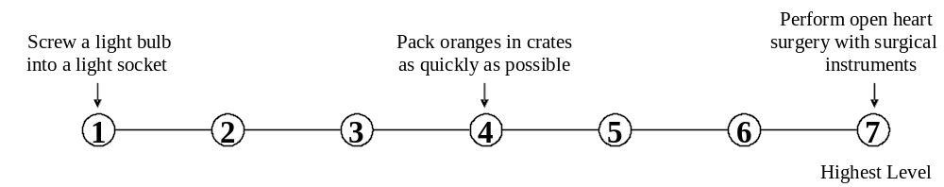

- Finger Dexterity | The ability to make precisely coordinated movements of the fingers of one or both hands to grasp, manipulate, or assemble very small objects.
A. How important is FINGER DEXTERITY to the performance of your current job?

* If you marked Not Important, skip LEVEL below and go on to the next activity.

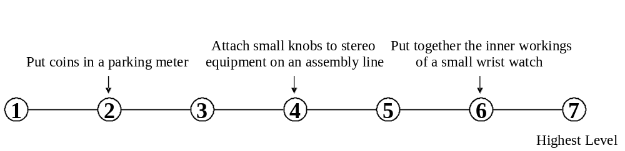B. What level of FINGER DEXTERITY is needed to perform your current job?

25. Control Precision | The ability to quickly and repeatedly adjust the controls of a machine or a vehicle to exact positions.
A. How important is CONTROL PRECISION to the performance of your current job?

* If you marked Not Important, skip LEVEL below and go on to the next activity.

B. What level of CONTROL PRECISION is needed to perform your current job?
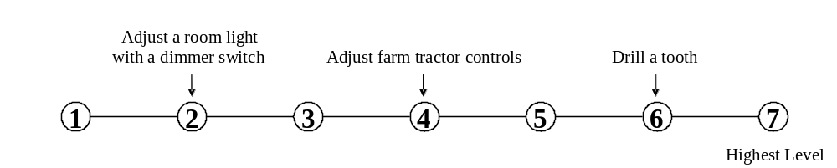

26. Multilimb Coordination | The ability to coordinate two or more limbs (for example, two arms, two legs, or one leg and one arm) while sitting, standing, or lying down. It does not involve performing the activities while the whole body is in motion.
A. How important is MULTILIMB COORDINATION to the performance of your current job?

* If you marked Not Important, skip LEVEL below and go on to the next activity.

B. What level of MULTILIMB COORDINATION is needed to perform your current job?
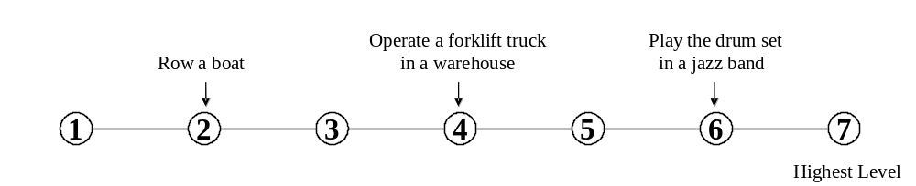

27. Response Orientation | The ability to choose quickly between “two or more movements” in response to “two or more different signals” (lights, sounds, pictures). It includes the speed with which the correct response is started with the hand, foot, or other body part.
A. How important is RESPONSE ORIENTATION to the performance of your current job?

* If you marked Not Important, skip LEVEL below and go on to the next activity.

B. What level of RESPONSE ORIENTATION is needed to perform your current job?
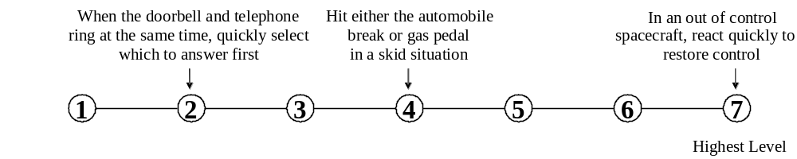

28. Rate Control | The ability to time your movements or the movement of a piece of equipment in anticipation of changes in the speed  and/or direction of a moving object or scene.
A. How important is RATE CONTROL to the performance of your current job?

* If you marked Not Important, skip LEVEL below and go on to the next activity.

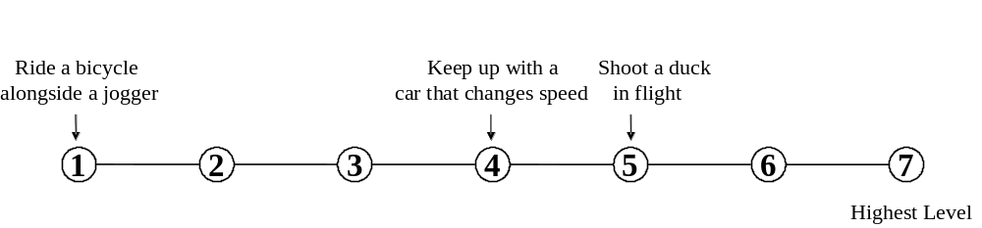B. What level of RATE CONTROL is needed to perform your current job?

- Reaction Time | The ability to quickly respond (with the hand, finger, or foot) to a signal (sound, light, picture) when it appears.
A. How important is REACTION TIME to the performance of your current job?

* If you marked Not Important, skip LEVEL below and go on to the next activity.

B. What level of REACTION TIME is needed to perform your current job?
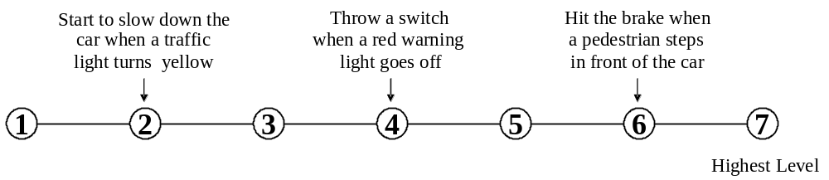

- Wrist-Finger Speed | The ability to make fast, simple, repeated movements of the fingers, hands, and wrists.
A. How important is WRIST-FINGER SPEED to the performance of your current job?

* If you marked Not Important, skip LEVEL below and go on to the next activity.

B. What level of WRIST-FINGER SPEED is needed to perform your current job?
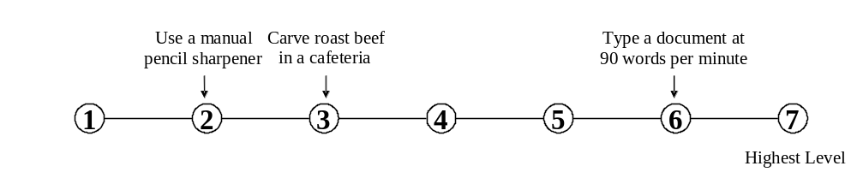

- Speed of Limb  Movement | The ability to quickly move the arms and legs.
A. How important is SPEED OF LIMB MOVEMENT to the performance of your current job?

* If you marked Not Important, skip LEVEL below and go on to the next activity.

B. What level of SPEED OF LIMB MOVEMENT is needed to perform your current job?
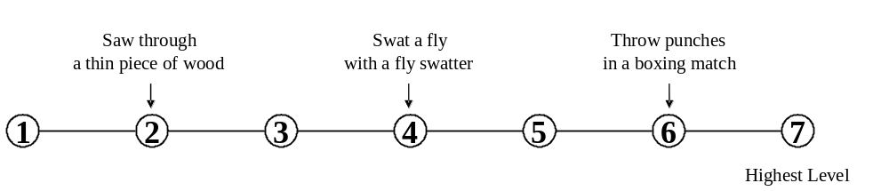

32. Static Strength | The ability to exert maximum muscle force to lift, push, pull, or carry objects.
A. How important is STATIC STRENGTH to the performance of your current job?

* If you marked Not Important, skip LEVEL below and go on to the next activity.

B. What level of STATIC STRENGTH is needed to perform your current job?
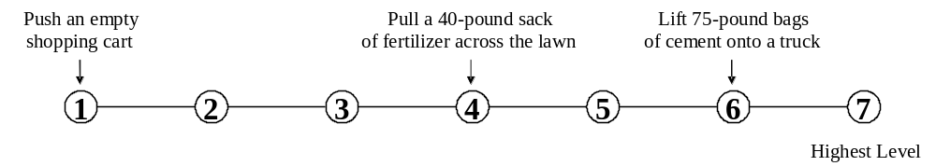

- Explosive Strength | The ability to use short bursts of muscle force to propel oneself (as in jumping or sprinting) or to throw an object.
A. How important is EXPLOSIVE STRENGTH to the performance of your current job?

* If you marked Not Important, skip LEVEL below and go on to the next activity.

B. What level of EXPLOSIVE STRENGTH is needed to perform your current job?
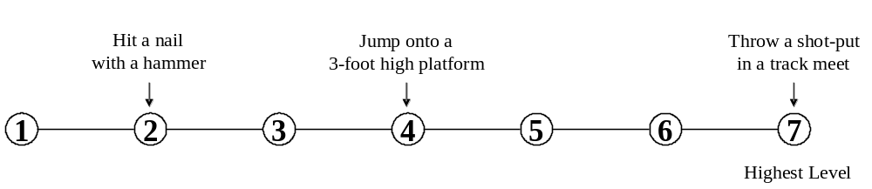

- Dynamic Strength | The ability to exert muscle force repeatedly or continuously over time. This involves muscular endurance and resistance to muscle fatigue.
A. How important is DYNAMIC STRENGTH to the performance of your current job?

* If you marked Not Important, skip LEVEL below and go on to the next activity.

B. What level of DYNAMIC STRENGTH is needed to perform your current job?
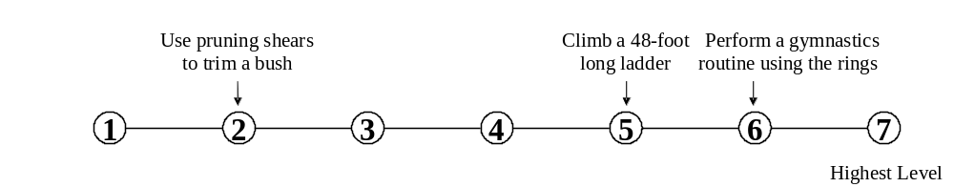

- Trunk Strength | The ability to use your abdominal and lower back muscles to support part of the body repeatedly or continuously over time without “giving out” or fatiguing.
A. How important is TRUNK STRENGTH to the performance of your current job?

* If you marked Not Important, skip LEVEL below and go on to the next activity.

B. What level of TRUNK STRENGTH is needed to perform your current job?
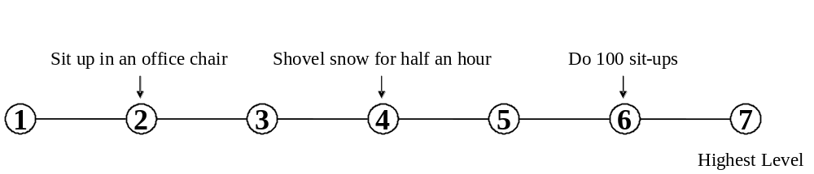

- Stamina | The ability to exert yourself physically over long periods of time without getting winded or out of breath.
A. How important is STAMINA to the performance of your current job?

* If you marked Not Important, skip LEVEL below and go on to the next activity.

B. What level of STAMINA is needed to perform your current job?
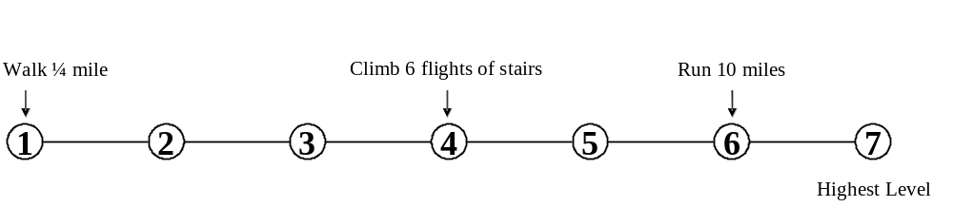

- Extent Flexibility | The ability to bend, stretch, twist, or reach with your body, arms, and/or legs.
A. How important is EXTENT FLEXIBILITY to the performance of your current job?

* If you marked Not Important, skip LEVEL below and go on to the next activity.

B. What level of EXTENT FLEXIBILITY is needed to perform your current job?
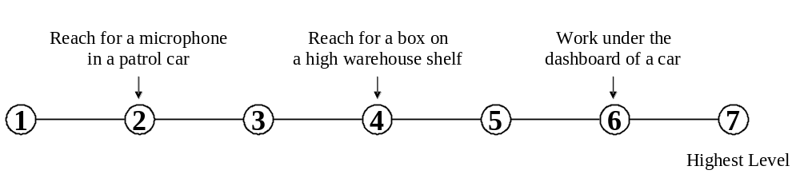

- Dynamic Flexibility | The ability to quickly and repeatedly bend, stretch, twist, or reach out with your body, arms, and/or legs.
A. How important is DYNAMIC FLEXIBILITY to the performance of your current job?

* If you marked Not Important, skip LEVEL below and go on to the next activity.

B. What level of DYNAMIC FLEXIBILITY is needed to perform your current job?
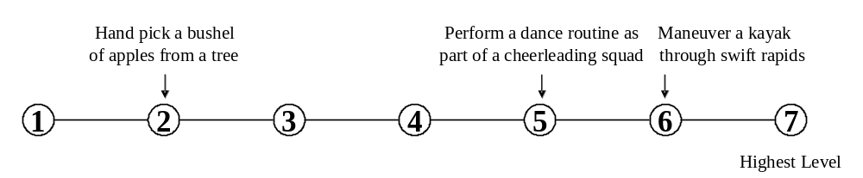

39. Gross Body  Coordination | The ability to coordinate the movement of your arms, legs, and torso together when the whole body is in motion.
A. How important is GROSS BODY COORDINATION to the performance of your current job?

* If you marked Not Important, skip LEVEL below and go on to the next activity.

B. What level of GROSS BODY COORDINATION is needed to perform your current job?
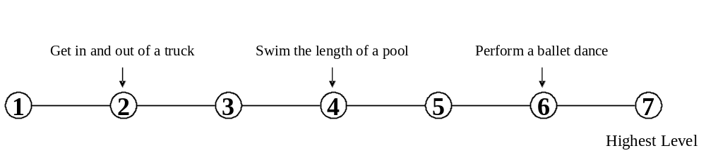

40. Gross Body Equilibrium | The ability to keep or regain your body balance or stay upright when in an unstable position.
A. How important is GROSS BODY EQUILIBRIUM to the performance of your current job?

* If you marked Not Important, skip LEVEL below and go on to the next activity.

B. What level of GROSS BODY EQUILIBRIUM is needed to perform your current job?
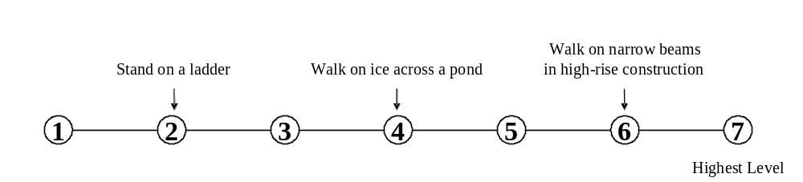

- Near Vision | The ability to see details at close range (within a few feet of the observer).
A. How important is NEAR VISION to the performance of your current job?

* If you marked Not Important, skip LEVEL below and go on to the next activity.

B. What level of NEAR VISION is needed to perform your current job?
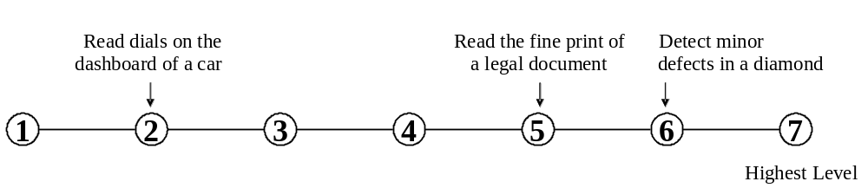

- Far Vision | The ability to see details at a distance.

A. How important is FAR VISION to the performance of your current job?

* If you marked Not Important, skip LEVEL below and go on to the next activity.

B. What level of FAR VISION is needed to perform your current job?
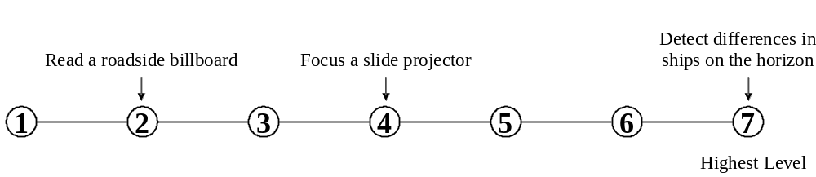

- Visual Color Discrimination | The ability to match or detect differences between colors, including shades of color and brightness.
A. How important is VISUAL COLOR DISCRIMINATION to the performance of your current job?

* If you marked Not Important, skip LEVEL below and go on to the next activity.

B. What level of VISUAL COLOR DISCRIMINATION is needed to perform your current job?
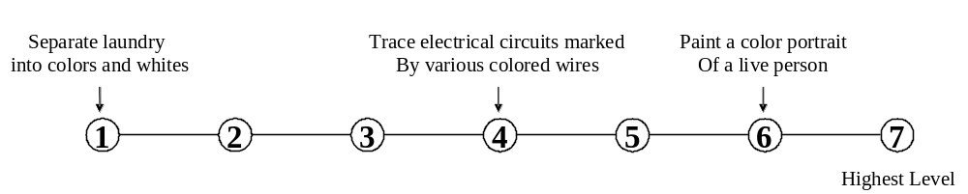

- Night Vision | The ability to see under low-light conditions.
A. How important is NIGHT VISION to the performance of your current job?

* If you marked Not Important, skip LEVEL below and go on to the next activity.

B. What level of NIGHT VISION is needed to perform your current job?

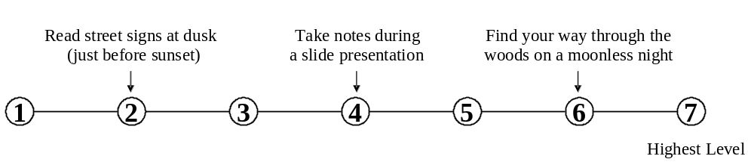

- Peripheral Vision | The ability to see objects or movement of objects to one’s side when the eyes are looking ahead.
A. How important is PERIPHERAL VISION to the performance of your current job?

* If you marked Not Important, skip LEVEL below and go on to the next activity.

B. What level of PERIPHERAL VISION is needed to perform your current job?
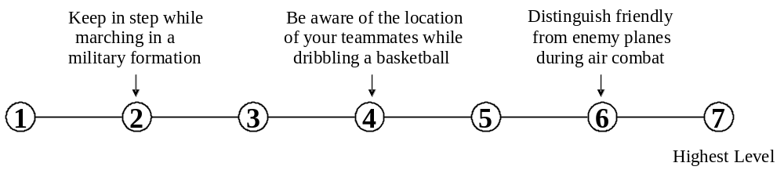

- Depth Perception | The ability to judge which of several objects is closer or farther away from you, or to judge the distance between you and an object.
A. How important is DEPTH PERCEPTION to the performance of your current job?

* If you marked Not Important, skip LEVEL below and go on to the next activity.

B. What level of DEPTH PERCEPTION is needed to perform your current job?
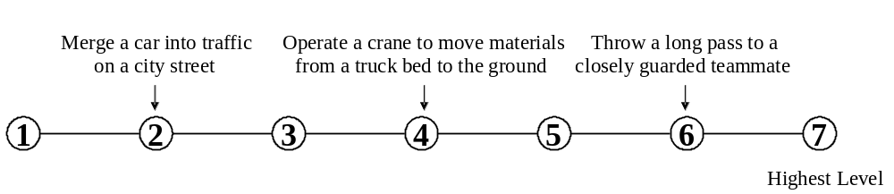

- Glare Sensitivity | The ability to see objects in the presence of a glare or bright lighting.
A. How important is GLARE SENSITIVITY to the performance of your current job?

* If you marked Not Important, skip LEVEL below and go on to the next activity.

B. What level of GLARE SENSITIVITY is needed to perform your current job?
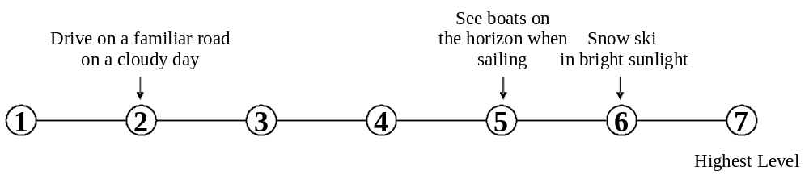

- Hearing Sensitivity | The ability to detect or tell the differences between sounds that vary in pitch and loudness.
A. How important is HEARING SENSITIVITY to the performance of your current job?

* If you marked Not Important, skip LEVEL below and go on to the next activity.

B. What level of HEARING SENSITIVITY is needed to perform your current job?
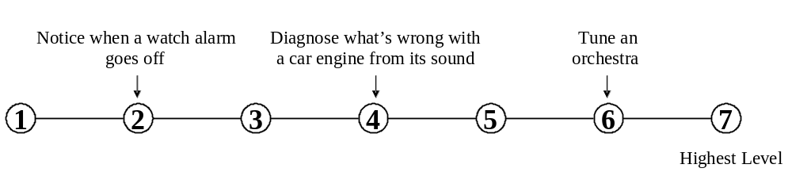

- Auditory Attention | The ability to focus on a single source of sound in the presence of other distracting sounds.
A. How important is AUDITORY ATTENTION to the performance of your current job?

* If you marked Not Important, skip LEVEL below and go on to the next activity.

B. What level of AUDITORY ATTENTION is needed to perform your current job?
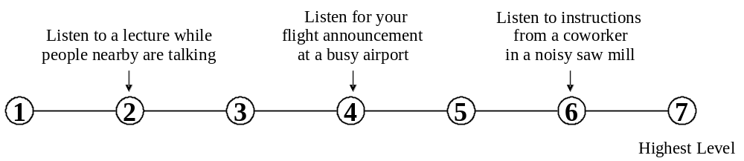

- Sound Localization | The ability to tell the direction from which a sound originated.
A. How important is SOUND LOCALIZATION to the performance of your current job?

* If you marked Not Important, skip LEVEL below and go on to the next activity.

B. What level of SOUND LOCALIZATION is needed to perform your current job?
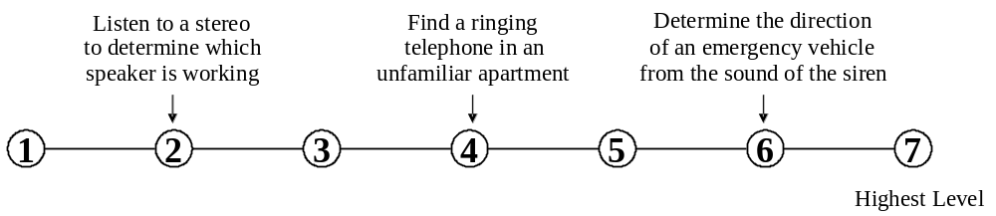

- Speech Recognition | The ability to identify and understand the speech of another person.
A. How important is SPEECH RECOGNITION to the performance of your current job?

* If you marked Not Important, skip LEVEL below and go on to the next activity.

B. What level of SPEECH RECOGNITION is needed to perform your current job?
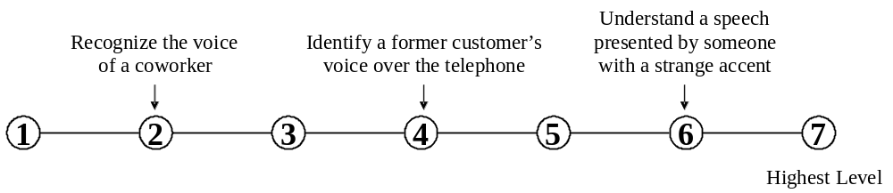

- Speech Clarity | The ability to speak clearly so others can understand you.
A. How important is SPEECH CLARITY to the performance of your current job?

* If you marked Not Important, skip LEVEL below and go on to the next activity.

B. What level of SPEECH CLARITY is needed to perform your current job?
